1. **Description**

We show step-wise details of employing the SCRG method to solve the LP relaxation of the Standard LSND model. The problem formulation and the algorithm description of the SCRG method (see Fig 1) can be found in the manuscript titled “A Simultaneous Column-and-Row Generation Solution Method for Liner Shipping Network Design”.

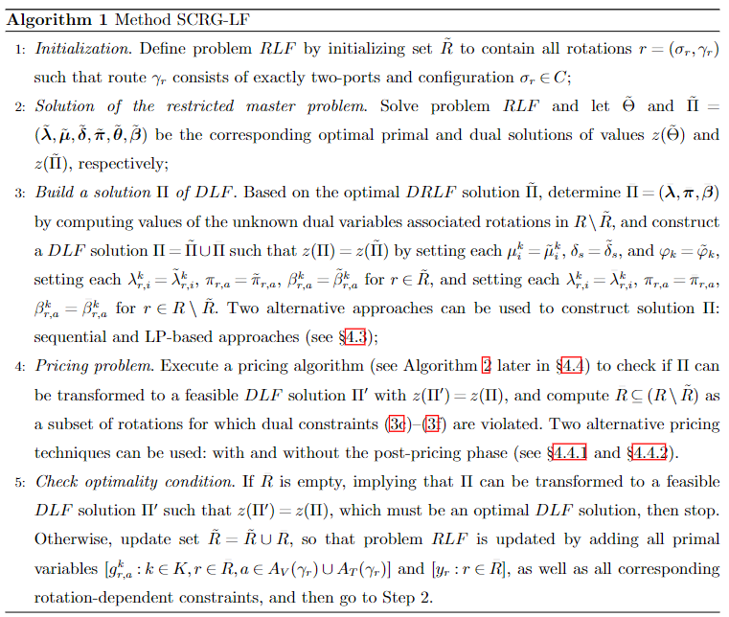

Fig 1. Algorithm of the SCRG method for solving the LP relaxation

1. **Solution details**

The solution details of instance A-p7d8s6 are presented. Instance A-p7d8s6 consists of 7 ports, 8 demand o-d pairs, and 6 ships of two types (i.e., 4 ships of “Feeder_450” and 2 ships of “Feeder_800”). The underlying digraph has 14 nodes (i.e., 7 voyage nodes and 7 transshipment nodes) and 56 arcs (i.e., 42 voyage arcs and 14 loading/unloading arcs). The complete data for the instance can be found from the Github folder “DataSet and Instances”.

Solving A-p7d8s6 via the SCRG method totally proceed 9 steps. The step-wise details of the solution procedure are as follows.

1. Initialization. Generate initial rotation set $\tilde{R}$. Two-port cycles combining with two ship types totally generates 36 initial rotations (see Fig 2). Based on the initial rotations, the Restricted Master Problem (RMP) of the LP relaxation model consists of 36 integer variables (i.e., y variables, or rotation design variables) and 1736 continuous variables (i.e., g and x variables, or cargo demand flow variables). Moreover, the RMP involves 576 constraints (1b), 56 constraints (1c), 2 constraints (1d), 72 constraints (1e), and 576 constraints (1f), where constraints (1b-1f) can be found from the paper.

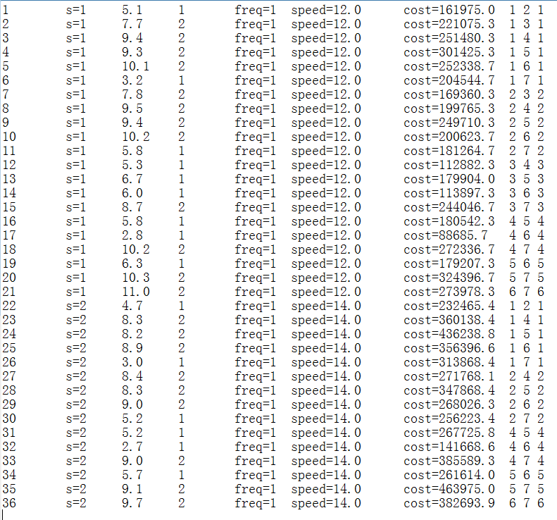

Fig 2. Initial rotations

1. Solution of the RMP. Solving RMP and obtain its optimal solution objective value 17429.8.
2. Build a solution $Π$ of DLF. Employ the LP-based method to compute the solution of DLF. It relies on an LP formulation with 868 variables and 672 constraints.
3. Pricing problem. Employ the Cycle Search Algorithm (CSA) to find the set $\overline{R}$  of new rotations to generate. Three new rotations as follows are returned by CSA, and then the rotation set $\tilde{R}$ includes 39 rotations now.



1. Checking optimality condition. Since set $\overline{R}$ is not empty, new variables and constraints that are associated with the new rotations in $\overline{R}$ are added into RMP. Specifically, 243 new variables are generated, including 3 rotation design variables (y variables) and 240 cargo flow variables (g variables). Moreover, 170 new constraints are generated, including 80 constraints (1b), 10 constraints (1e), and 80 constraints (1f).
2. Solution of the RMP. Solving RMP and obtain its optimal solution objective value 46211.6.
3. Build a solution $Π$ of DLF. Employ the LP-based method to compute the solution of DLF. It relies on an LP formulation with 868 variables and 672 constraints.
4. Pricing problem. Employ the Cycle Search Algorithm (CSA) to find the set $\overline{R}$  of new rotations to generate. No new rotation is returned by CSA and rotation set $\overline{R}$  is hence empty.
5. Checking optimality condition. Since set $\overline{R}$ is empty, SCRG method stops with the optimal LP solution found.
6. **Detailed information of the optimal LP solution**

The optimal LP objective value: 46211.6

* y=0.0111 for rotation 7, where the route is “DEBRV -> RUKGD -> DEBRV” and the configuration (i.e., ship type) is “Feeder_800”. There is 1 ship deployed to maintain weekly frequency.
* y=0.0111 for rotation 8, where the route is “DEBRV -> FIKTK -> DEBRV” and the configuration (i.e., ship type) is “Feeder_800”. There is 1 ship deployed to maintain weekly frequency.
* y=0.5844 for rotation 37, where the route is “DEBRV -> FIKTK -> RUKGD -> DEBRV” and the configuration (i.e., ship type) is “Feeder_450”. There are 2 ships deployed to maintain weekly frequency.
* y=0.4044 for rotation 38, where the route is “DEBRV -> RUKGD -> FIKTK -> DEBRV” and the configuration (i.e., ship type) is “Feeder_450”. There are 2 ships deployed to maintain weekly frequency.
* x=7.0000 for demand 2, i.e., “RUKGD -> DEBRV”
* x=268.0000 for demand 5, i.e., “DEBRV -> RUKGD”
* x=187.0000 for demand 8, i.e., “DEBRV -> FIKTK”
* g=0.0778 for demand 2 on voyage arc “RUKGD -> DEBRV” of rotation 7
* g=0.0778 for demand 2 on loading arc “RUKGD -> RUKGD” of rotation 7
* g=0.0778 for demand 2 on unloading arc “DEBRV -> DEBRV” of rotation 7
* g=2.9778 for demand 5 on voyage arc “DEBRV -> RUKGD” of rotation 7
* g=2.9778 for demand 5 on loading arc “DEBRV -> DEBRV” of rotation 7
* g=2.9778 for demand 5 on unloading arc “RUKGD -> RUKGD” of rotation 7
* g=2.0222 for demand 8 on voyage arc “DEBRV -> RUKGD” of rotation 7
* g=2.0222 for demand 8 on loading arc “DEBRV -> DEBRV” of rotation 7
* g=2.0222 for demand 8 on unloading arc “RUKGD -> RUKGD” of rotation 7 (transshipment)
* g=2.9222 for demand 5 on voyage arc “DEBRV -> FIKTK” of rotation 8
* g=2.9222 for demand 5 on loading arc “DEBRV -> DEBRV” of rotation 8
* g=2.9222 for demand 5 on unloading arc “FIKTK -> FIKTK” of rotation 8 (transshipment)
* g=2.0778 for demand 8 on voyage arc “DEBRV -> FIKTK” of rotation 8
* g=2.0778 for demand 8 on loading arc “DEBRV -> DEBRV” of rotation 8
* g=2.0778 for demand 8 on unloading arc “FIKTK -> FIKTK” of rotation 8
* g=153.7089 for demand 5 on voyage arc “DEBRV -> FIKTK” of rotation 37
* g=109.2911 for demand 8 on voyage arc “DEBRV -> FIKTK” of rotation 37
* g=4.0911 for demand 2 on unloading arc “DEBRV -> DEBRV” of rotation 37
* g=4.0911 for demand 2 on voyage arc “RUKGD -> DEBRV” of rotation 37
* g=156.6311 for demand 5 on unloading arc “RUKGD -> RUKGD” of rotation 37
* g=156.6311 for demand 5 on voyage arc “FIKTK -> RUKGD” of rotation 37
* g=109.2911 for demand 8 on unloading arc “FIKTK -> FIKTK” of rotation 37
* g=153.7089 for demand 5 on loading arc “DEBRV -> DEBRV” of rotation 37
* g=109.2911 for demand 8 on loading arc “DEBRV -> DEBRV” of rotation 37
* g=4.0911 for demand 2 on loading arc “RUKGD -> RUKGD” of rotation 37
* g=2.9222 for demand 5 on loading arc “FIKTK -> FIKTK” of rotation 37 (transshipment)
* g=108.3911 for demand 5 on voyage arc “DEBRV -> RUKGD” of rotation 38
* g=73.6089 for demand 8 on voyage arc “DEBRV -> RUKGD” of rotation 38
* g=2.8311 for demand 2 on unloading arc “DEBRV -> DEBRV” of rotation 38
* g=2.8311 for demand 2 on voyage arc “RUKGD -> FIKTK” of rotation 38
* g=75.6311 for demand 8 on voyage arc “RUKGD -> FIKTK” of rotation 38
* g=108.3911 for demand 5 on unloading arc “RUKGD -> RUKGD” of rotation 38
* g=2.8311 for demand 2 on voyage arc “FIKTK -> DEBRV” of rotation 38
* g=75.6311 for demand 8 on unloading arc “FIKTK -> FIKTK” of rotation 38
* g=108.3911 for demand 5 on loading arc “DEBRV -> DEBRV” of rotation 38
* g=73.6089 for demand 8 on loading arc “DEBRV -> DEBRV” of rotation 38
* g=2.8311 for demand 2 on loading arc “RUKGD -> RUKGD” of rotation 38
* g=2.0222 for demand 8 on loading arc “RUKGD -> RUKGD” of rotation 38 (transshipment)